Who’s?
Write the questions or the answers.
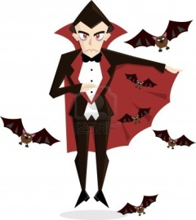 Who’s he? He’s Dracula.
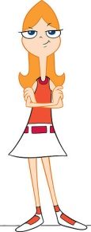 Who’s she? ______________________
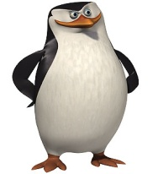 ____________________ He’s Skipper.
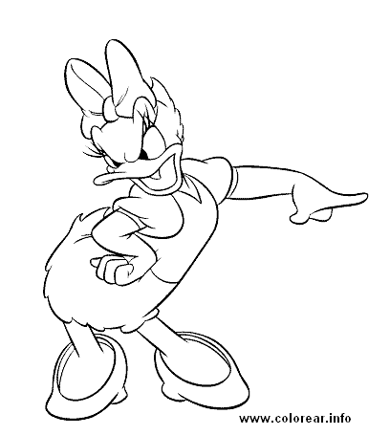 Who’s she? ___________________
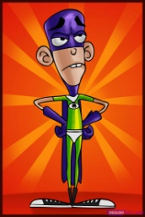 _________________ He’s Fanboy.

Who are you? ____________________

